Module 6 Exam Summer 2020
Student’s Name
Course Title
Date

Question 1
Solution
Aggregate supply (A.S) under both models is downward sloping. A.S relates output with price but it has several implications. The ranges for A.S curve are;
- Keynesian range.
- Classical range.
- Intermediate range.
In Keynesian range, the A.S (Aggregate supply) remains horizontal in the short run denoting any stimulus by the state that shifts the A.D (Aggregate demand) up to the right has no effect on the price. The entire increase is absorbed by the output level which tends to increase by full. This indicates that wages and prices are assumed to be rigid and unresponsive particularly to any change in the demand. Sticky wage and price is the result of unwillingness of firms to frequently change the price and that of employers who make formal contracts of nominal wages for a fixed tenure.
In classical range, A.S is vertical denoting any stimulus by the government in place that shift the A.D up to the right, has no effect on the output. The entire increase is absorbed by the price level. This indicates that wages and prices are assumed to be readily flexible and any change in the A.D will to a great extend stimulate prices and wages so that real output is unchanged.
In intermediate range, A.S is upward sloping, indicating a vibrant positive relationship between price and real Gross domestic product. Under this given range, when A.D shifts say like both price level and output level are changed simultaneously. This is based on the fact that prices are flexible in the short run but wages are sticky.
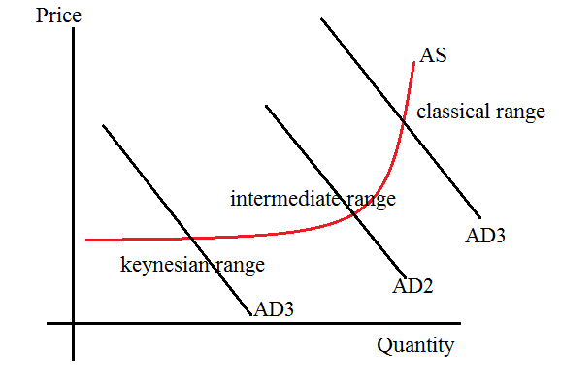
Based on the general graph above, the price of oil can be affected in the following ways;
Price ShortRAS1
Long RAS Short RAS2

B
P₁

Pf A

AD₁

Y₁ Yf Real GDP

As demonstrated above, in the short run, there is a leftward shift of the SRAS supply which reduces the real Gross domestic product but raises the price

Price Long RAS
Short RAS2 Short RAS1

B
P₁

Pf A

AD₁

Real GDP Y₁ Yf
In the long run,as the price level rises,real wages fall and firms hire more labor,which increases production and shifts the SRAS curve directly back to its original location.Consequently,both the prices and Real GDP have reached their original long run levels.
Question 2
Solution
Despite the fact that 2019 registered a slight increase rate of 2.1% .The Current U.S GDP dollar in the first quarter of 2020 is estimated to have registered a decrease of approximately 3.4%, or $189.4 billion, in the first quarter to a level of $21.54 trillion. This implies that there is a recessionary gap of negative GDP gap. This suggests that the intersection of SRAS and AD must be occurring before the full employment level (before its LRAS curve). Figure suggests that the US economy is operating at E1.
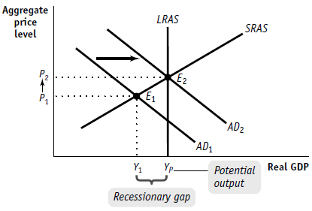
Question 3
Solution
A SR Phillips curve demonstrates the relationship between inflation and unemployment. In most cases, it cuts across the natural unemployment rate and the expected inflation rate does demonstrating a roughly an L-shaped which reflects the initial inverse relationship between the inflation and unemployment. In the event that inflation rises above the expected rate, the rate of unemployment will basically rise slightly above the natural rate, as a result, the Philips Curve takes a negative slope in the short-run.
As demonstrated in the graph below; if the economy expects inflation rate is 7%, the natural rate of unemployment exists at 5% and it is equilibrium at point A. In the same manner, if it expects inflation rate is 9%, the natural rate of unemployment decreases to 3% and it is equilibrium at point B. This clearly indicates the inverse relationship between the inflation rate and unemployment rate.

Inflation
Rate

Expected Rate 9 B
Of inflation 7 A

SRPC
3 5 Unemployment rate
Natural Rate
Question 4
Solution
We can state that these ranges have to a greater extent been used to illustrate the condition of economy.
Range A
When the Aggregate demand curve is in range A.it implies that the economy basically tends to operate below the full employment level or in other terms it can be stated that demand is deficient, hence it is not sufficient to increase both employment and output. Hence, Fiscal and monetary policies must be applied to speed up the level of aggregate demand in economy.
In this regard, the government has an obligation to follow both monetary expansionary fiscal policies as an approach of attaining full employment in an economy. If the government focuses on using both Monitory and expansionary policies, there will be rise in Aggregate demand and it will shift to right thereby pulling up both output and employments. This means that the government to take drastic measures such as increase expenditure and at the same time reduces taxes. Consequently, from the monitory side, the government should focus on opening market purchase of securities and reducing the reserve requirements.
Range C
On other side, in range C, it can be seen that the economy is at full employment level and government has an obligation of switching from expansionary actions to contractionary actions. The measures and policies that need to be taken here include; reducing the level of expenditure and increasing the tax rate level. At the same time, reserve requirements have to be increased. We can therefore conclude that, these kinds of measures would to agreater extent moderate aggregate demand. Expansionary policies in this range might lead to rise in inflationary pressures.
Question 5
Solution
Article: Expansionary monetary policy implementation increases the price level in an economy.
It could be discussed as below: AE—AD curves: Given the following;
- Consumption expenditure = C
- Net export (NE) = Export – Import
- Government spending = G
- Investment spending = I
- Net export (NE) = Export – Import
Aggregate expenditure (AE) = C + I + G + NE
Aggregate demand = AD
The 45 degree line ought to intersect the AE-curve to get the desired and actual level of expenditures. A perpendicular line on such point to the AD-curve shows the equilibrium point Eq. At this point the real gross domestic product is Qm and the price is Pm.
Suppose a macroeconomic monetary policy is taken, like expansion policy. It increases consumption expenditure (C), causing shifting of AE1 to AE2. The new equilibrium becomes Eq1 at Q2 real gross domestic product and P2 price. The price increases by PmP2 because of inflation.
As demonstrated by the graph below, it can be noted that since the price level Increases from Pm to P2, the demand point on AD moves mainly from point Eq to another point which is Eq1.Hence decreasing the level of real Gross domestic product from Qm to Q2

The required Graph is as shown below:
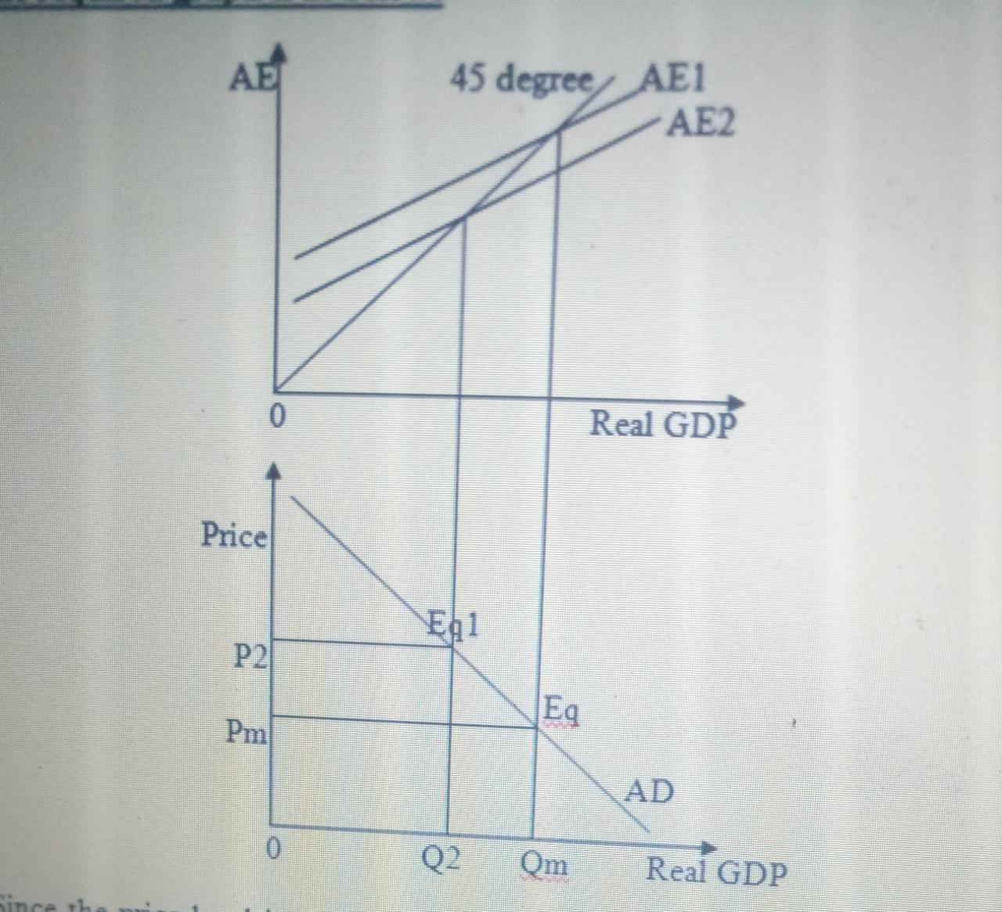

Question 6

Solution
Despite the fact that a weaker dollar tends to increase the exports, a stronger dollar would attract more investments which tends to increase the productivity of a country hence making it as a country to stay more competitive. A strong dollar therefore increases the standards of living of the populace and increases their purchasing power both in the short run and in the long run. With this in mind, a stronger dollar will be the best option we might want.

Question 7
Solution
The covid-19 pandemic has dramatically affected the economic status of many nations around the globe. Due to the current lack of a vaccine, the crisis seems far from being over, implying that countries will keep on suffering economically. However, Economists around the world are working on a better economic recovery. Economic recovery refers to all business improvement activities that follow after a recession in the economy. The recovery process is characterized by adjustments of nations to new conditions, the invention of new measures to counter the factors that lead to the recession, and a changed economic adaptation. There are several paths to recovery, as outlined below.
The L- shaped recovery scheme is a mode of recovery that occurs after an economic recession characterized by a steep reduction of the economy. It is a discouraging shape. It does not happen at a fast rate, and some of its characteristics include continued unemployment and stagnant economic development (Carlsson-Szlezak et al. 2020). The Covid-19 pandemic has led to the closure of many businesses. It has led to increased rates of losing jobs, especially in the majority of the developing nations. This signifies that unemployment will be persistent, and the economy will regain its initial status after a considerably more extended time. On the other hand, the V-shaped economic recovery is a type of restoration where the economy bounces to its initial state before a crisis happens. It involves the quick recovery of the economy with little or no economic hiccups as the process occurs. It is an optimistic strategy that implies that a particular crisis caused little damage to the economy, and the cost wouldn't last long. On the effects of the covid-19 crisis, a V-shaped pattern may work efficiently in developed nations rather than the developing countries. Finally, the U-shaped recovery pattern refers to a recovery pattern where the economic damage exists for a more extended period before settling at the average level of growth. This means that the loss tends to last for a while despite the economic bounce to its initial status (Sharma et al., 2020).

References
Sharma, D., Bouchaud, J. P., Gualdi, S., Tarzia, M., & Zamponi, F. (2020). V-, U-, L-or W-shaped recovery after COVID? Insights from an Agent-Based Model. Insights from an Agent-Based Model (June 15, 2020).
Carlsson-Szlezak, P., Reeves, M., & Swartz, P. (2020). What coronavirus could mean for the global economy? Harvard Business Review, 3.

